**Miscellaneous Questions**

**Type – 1**

**Fill–in/Completion Questions**

Q 1. If (1 + x + x2 + x3)7 = then the value of a0 + a4 + a8 + a12 + a16 + a20 is

Q 2. The number of different ways in which 24 apples can be distributed among 3 boys and 3 girls such that the total number of apples received by boys is double that received by the girls is

Q 3. Ifthen  is equal to

Q 4. Three times the least value of the area bounded by the line y = mx+1 and the parabola y = x +2x-3,m being a parameter, is

Q 5. If f(x) and §(x) are continuous functions in [0, 4] satisfying f(x) = f(4 - x), <|>(x) + (4 - x) = 3 and φ(x) + φ(4 – x) = 3and dx = 2 then the value ofφ(x) dx is

Q 6. is equal to

Q 7. If f(x) =dx (x > 0) anddx =  then f(50) is

Q 8. Consider the closed figure C made by the lines |x| + |y| – . Let S be the region inside the figure C such that any point in it is nearer to the side x + y =  than the origin. Then three times the area of S is

Q 9. If ai,≥ 0, where i =1,2,3,.. .,n, and then the greatest possible value ofis

Q 10. Let 2 be divisible by 4, where a1, a2,a3,a4, a5 are digits. The largest possible number of values of (a1, a2, a3, a4, a5) is

Q 11. Let f(x) = ax4 + bx3 + cx2 + dx + λ, where and = 1. If f(i) + f() + k = 0, where z =, then k is

Q 12. A plane exists which is perpendicular to the line and passes through the line . Then k is

**Answers**

1.4096 2.6885 3.10 4.32 5.3

6.45 7.10 8.4. 9.100 10.45000

11. 20 12.10

**Note**  If the answers of completion questions are whole numbers then the answers may be given by shading properly in a matrix of digits as shown below.

For example, the answer '4096', i.e., '04096', of **Q.1** can be shown as below by shading:

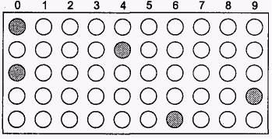

The answer '10', i.e., '00010', of **Q.12** can be shown as below by shading:

